Romanian NMA Training Placement Scheme
First semestrial scientific report, April 2025

Claudiu Adam (EUMETSAT Placement Scheme Trainee, NMA),
Eugen Mihuleț (NMA)

Objectives of the program
The objective of the placement scheme is to adapt and integrate an established ML-based nowcasting system, i.e. COALITION-4 (Coalition-4), that aligns with the NMA's needs for automating the severe weather warning issuance chain, ensuring high precision in the 0–1 hour lead times for heavy rain, hail, and lightning prediction. The implemented model integrates weather radar data, satellite imagery (FCI), lightning detection sensors, NWP model output, and a Digital Elevation Model of Romania.
As the program is intended to be relevant also outside the national context, the entire adaptation of the process is documented and the new developed code will be available on the MeteoSwiss github, enabling its use by other EUMETSAT member states.
Besides the primary objective of integrating the COALITION-4 in NMA’s operational chain, as the field of AI in nowcasting is evolving at high pace and promising solutions emerge constantly, within the program alternative models will be assessed and the most promising will be further investigated.

Assumptions and constraints
During the first month and a half of the program, an analysis was performed in order to assess whether a new solution should be developed, or adapting an existing model would be a more efficient approach. Given the resources constraints, the analysis indicated that the latter is more advisable, and it was opted for COALITION-4 as it demonstrated good performances in severe convection forecast (heavy rainfall, lightning and hail), with increased accuracy compared to traditional radar-based extrapolation methods, handling complex terrain and rapid weather changes with reduced error rates in short-term (below 1 hour) forecasts.
Several constraints specific to ML forecasting models need to be considered and if possible, handled. First, such models are heavily dependent on high-quality, dense historical weather data, thus low quality data or reduced datasets will result in poor performance of the models. In this specific context, for the training of the model, data collected during 2025 and 2026 convective seasons will be used as 1) FCI data will be employed, and the FCI data is available only since September 2024, 2) there are no archives for the needed NWP outputs and it would be computing-expensive to run the models retroactively, and 3) some of the required radar products were not produced operationally and it would be resource-intensive generating these products retroactively. The reduced length of the datasets might be a limitation, but COALITION-4 showed good results with training on data from just one convective season.
Another important constraint of data-driven nowcasting models is the inherent difficulty in capturing extreme values, as they may be underrepresented in the training data, and which are actually the values of most importance for the meteorologists. This issue could be approached by curating the datasets used for training in the sense of selecting days with relevant convective activity with the goal of maximizing the weight of severe weather events in the training set.
In terms of adaptation of nowcasting ML model to a new geographic region, another limitation of this approach is the fact that models developed and optimized in one geographical or climatic context may not perform well when applied to a different region with different topographic and climatic characteristics, an issue that is not related to training sets, which are region specific.

Technical framework

COALITION-4 is a recurrent-convolutional deep learning model that utilizes an encoder-decoder structure with residual connections. The architecture incorporates convolutional layers for spatial feature extraction, recurrent connections between timesteps to capture temporal dynamics, along with downsampling and upsampling layers to process multi-resolution data. These components are connected through concatenation operations that combine features from different sources and resolutions, culminating in a final convolutional layer that produces the prediction outputs. The model can process input data at a high spatial resolution (1 km) and at a low spatial resolution (4 km).
The architecture structure can process various data sources including radar, satellite, lightning, numerical weather prediction, and digital elevation model inputs. The input source dimensions vary from 256×256 for high-resolution data and 64×64 for low-resolution data. This configuration enables the model to process 6 past time steps while generating predictions for 12 future time steps.
The input data has a temporal resolution of 5 or 10 minutes and varies in spatial resolution, between 1 and 4 km, 10% allocated for validation and another 10% for testing, with 80% remaining for the training phase. It results in 96 combinations of targets and data sources.
For optimization, the model employs different loss functions depending on the prediction target, such as focal loss for lightning prediction, and cross-entropy loss for hail and precipitation prediction.
The model demonstrates varying performance across different hazard types, achieving Critical Success Index scores for lightning prediction of 0.767 (5 min), 0.544 (15 min), 0.443 (30 min), and 0.317 (60 min); for hail prediction of 0.454 (5 min), 0.267 (15 min), 0.140 (30 min), and 0.057 (60 min); and for heavy precipitation prediction (60 min accumulation) of 0.320 (R > 10 mm), 0.182 (R > 30 mm), and 0.131 (R > 50 mm) (Leinonen, 2023). It is also highlighted that radar data proved to be the most valuable predictor for all three hazard types.
On our side, the hardware environment used for the development of the model and data fetching and preprocessing consists of:
- CPU: Intel Xeon Gold 6234 with 3.3 GHz clock frequency
- GPU: NVIDIA RTX A6000
- RAM: 64 GB capacity
- Storage space: SSD of 2 TB capacity

For the software environment we used Windows 10 as the operating system. The model and scripts run on Python version 3.12.4 in a Conda environment in Visual Studio Code framework. The main libraries used in development are TensorFlow for model development, training, and evaluation, Xarray and Dask for handling larger-than-memory files and operating with them, scikit-learn used in determining the number of patches in the radar data through the use of DBSCAN (i.e. clustering algorithm), Numpy for efficiently solving standard mathematical operations, CuPy for porting demanding calculations on the GPU instead of the CPU, Eumdac for fetching satellite data, and Matplotlib for visualizing plots. We also used Panoply and QGIS for a comprehensive view of data and patches created.

The model will initially run on local NMA servers to ensure prediction consistency. We are also considering the possibility of deploying the resulting nowcasting model on the European Weather Cloud.
All data used for model training and evaluation consists of multiple data sources. After being fetched from local servers or from EUMETSAT servers, all data was preprocessed in advance for patch creation, with model training on NMA data being the main objective.
All data sources have around 5-minute temporal resolution and preprocessed using a function that identifies the optimal grid indices for creating a rectangular data patch by finding the closest points in a latitude-longitude coordinate matrix to specified upper-left and lower-right boundary coordinates, leveraging GPU acceleration to efficiently process large meteorological grids for the nowcasting model.
The data sources are:
- Radar – generated in NetCDF format, Leonardo weather radar, 7 sites in NMA’s network
- NWP – generated in NetCDF format, ICON model, 2.8 km spatial resolution
- Satellite – NAT files converted to NetCDF files, FCI data, 0.5 - 2 km spatial resolution
- Lightning – KML files converted to NetCDF files, LINET lightning detection network, 9 sensors in NMA’s network
- DEM – TIFF file converted to NetCDF file, 1 km spatial resolution

Development and implementation

The development in the first six months consisted of the following software implementations:
- Fetching and processing algorithms and scripts for NMA data;
- Optimizing the processing algorithms.

We adapted the projection used by the COALITION-4 model for its application in Romania. While the original model uses the Swiss projection (EPSG:21781), covering Switzerland and surrounding regions in an area spanning 710 km × 640 km, we reconfigured the system to use the Stereographic 1970 projection (EPSG:31700), which is the national reference system for Romania. The dimensions of the projection area were set to 1509×855 pixels, with a spatial resolution of 1 km. An important aspect of the configuration is the inclusion of a 256 km buffer zone around borders (for both the original Swiss area, and Romania). This buffer zone is not arbitrary but closely related to the patch architecture used in the nowcasting model, ensuring that processing at the edges is not affected by boundary effects.
This fetching and processing pipeline handles various types of meteorological data, processes them into a consistent NetCDF format, and prepares training patches for COALITION-4.
DEM data is transformed from TIFF format to NetCDF format. Terrain derivatives are calculated (i.e. east-west and north-south slopes). By extracting latitude and longitude coordinates from the georeferences and organizing outputs into structured directories, standardized topographical inputs are created for the nowcasting model. 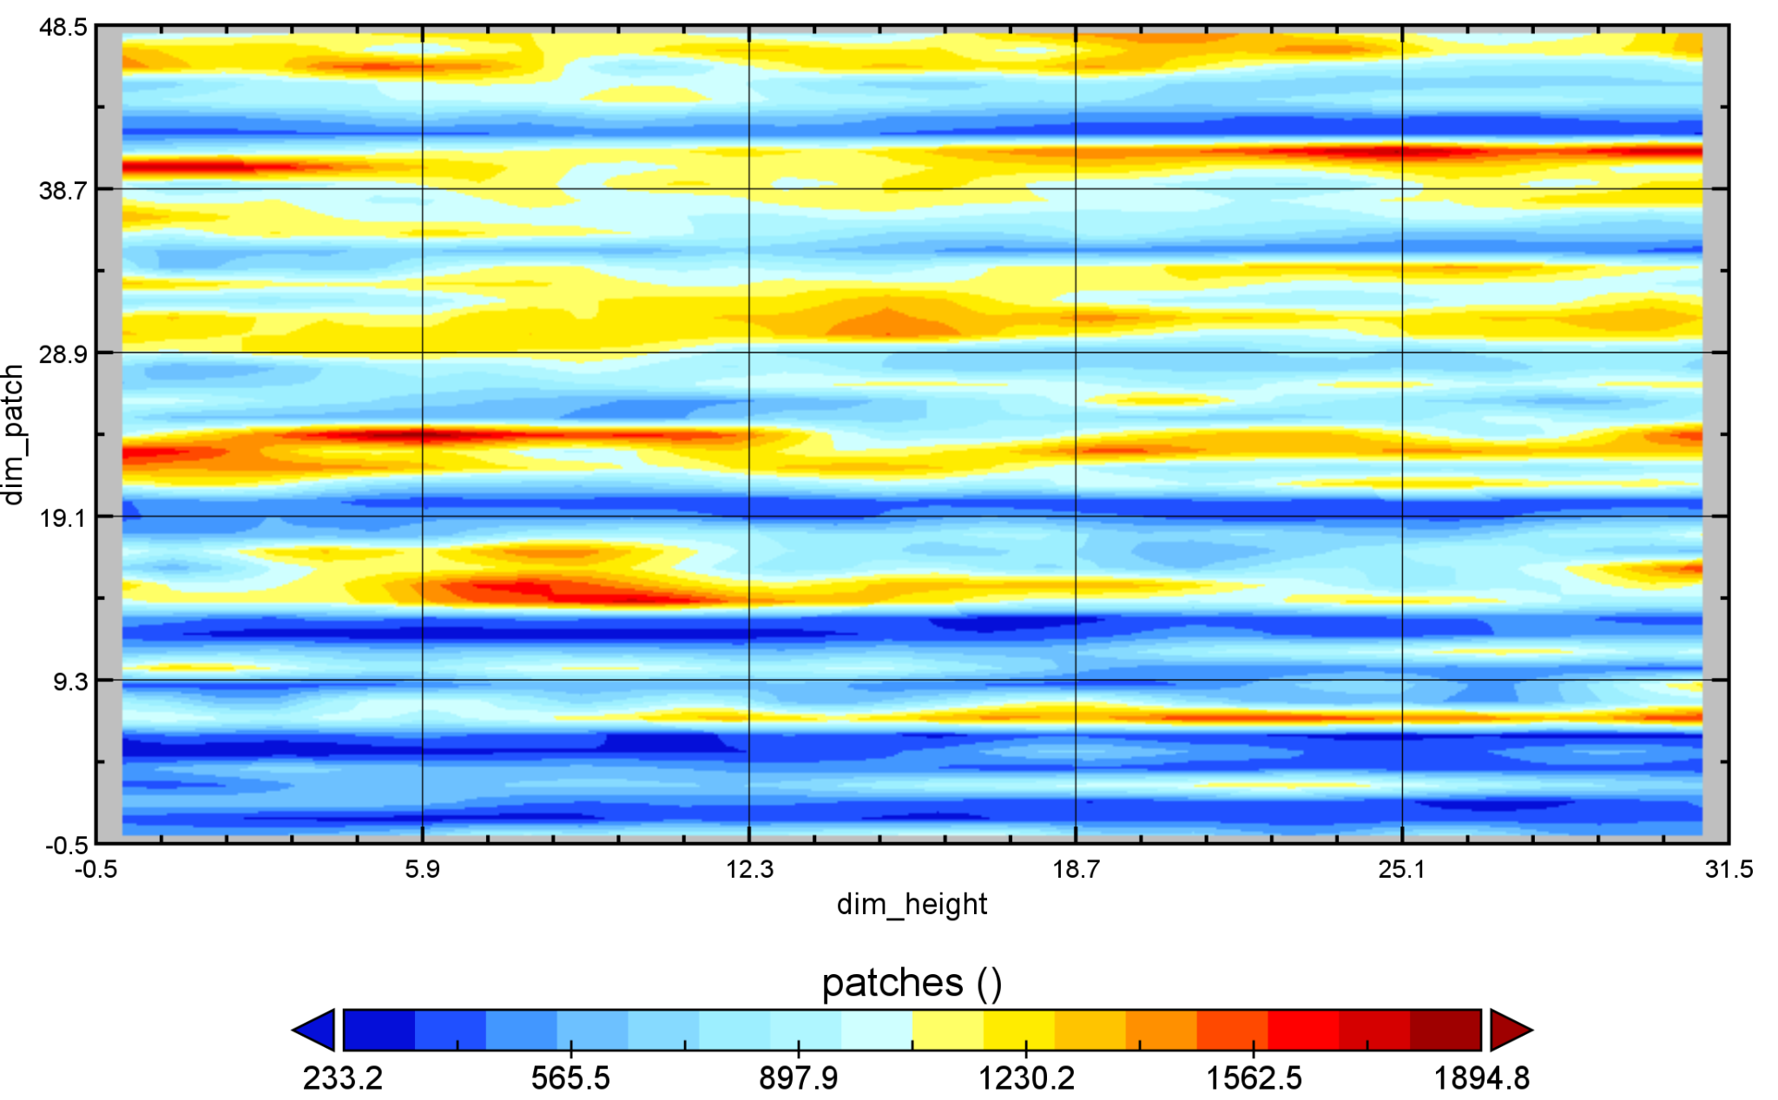
Figure 1 - Visual representation of DEM patches over Romania

All weather products used by COALITION-4 are made of concatenated patch matrices. Looking at the example from Fig. 1, we can see that the resulting map doesn’t resemble a topographic map, but rather a concatenation of pixel values from left to right of DEM patches. The colored scale represents the actual values of the pixels, the Ox axis (dim_height) represents the dimension of a patch (i.e. pixels of a 32x32 patch were averaged to get an array of 32 values), and the Oy axis (dim_patch) represents the total number of patches generated for that product.
Lightning data is transformed from individual lightning strikes stored in KML files into structured NetCDF datasets. 8 km resolution grids are created, covering Romania and other neighbour regions, then individual lightning strikes are mapped to the nearest grid points using GPU-accelerated algorithms. It generates binary occurrence maps, density maps, and current-weighted density maps at 5-minute time intervals. Optimization techniques are employed including batch processing, parallel execution via multiprocessing, and GPU acceleration through CuPy to handle intensive spatial operations. Processed lightning data provides information about electrical activity that correlates with severe weather development.
SEVIRI data (HRV, IR_016, IR_039, IR_087, IR_097, IR_108, IR_120, IR_134, VIS006, VIS_008, WV_062, WV_073) was first acquired from the EUMETSAT Data Store. The authentication is handled by the EUMETSAT API that downloads specific MSG data for the requested time period, and processes the raw satellite data into standardized NetCDF format. It organizes the resulting files into multiple directories, each directory representing a satellite product.
Radar data is provided by the NMA radar network, comprising seven radar sites. Data is received about every 5 minutes and consists of several base and derived products - Rain rate, Composite reflectivity, Reflectivity first elevation, Echotop 20 dBz, Echotop 45 dbz, Echotop, VIL and One hour precipitation.
The NWP model used is ICON 2.8 km, unlike the original COALITION-4 model that employs COSMO 2.8 model, as ICON shows in general better performance than COSMO in our region. The dataset is generated every 6 hours, with 12 or 24 hours lead time with a 5 minutes time step. The following parameters are being used: CAPE-MU (Convective Available Potential Energy - Most Unstable), CIN-MU (Convective Inhibition - Most Unstable), HZEROCL (Height of Zero Degree Celsius Level), LCL-ML (Lifting Condensation Level - Mixed Layer), MCONV (Moisture Convergence), OMEGA, SLI (Showalter Stability Index), SOILTYP (Soil Type), T-2M (Temperature at 2 Meters), T-SO (Soil Temperature).
All meteorological data sources are then processed into standardized training patches for COALITION-4. The main script processes radar, satellite, solar radiation, digital elevation, and lightning data based on command-line arguments, then identifies weather features by finding precipitation regions above a threshold value in the radar data and applying DBSCAN clustering to detect storm cells. For the radar data, a coordinate mapping system is implemented that aligns data from different sources using GPU-accelerated methods to find corresponding patches across various data types. By extracting 256x256 pixel patches around storm cluster centers and further dividing them into 32x32 pixel sub-patches, the script identifies each storm system. The function responsible for the approximation of the patches uses the latitude and longitude from different weather products and the latitude and longitude of the patches extracted from radar data. Due to the different pixel resolution of the products the first extracted patches are of different sizes, then further in the pipeline are interpolated into 32x32 in resolution. We managed to process and approximate the resolution of the DEM, lightning, and satellite products based on the resolution of the radar data. The resolution of different datamaps was approximated to keep the spatial resolution consistent across all weather products.
We wanted to optimize the data preprocessing pipeline. Weather data processing can be accelerated through a combination of parallel processing techniques, GPU acceleration, and numerical methods. By implementing concurrent file operations, large-scale meteorological data can be processed simultaneously on all available threads of the CPU rather than sequentially. Moving computationally intensive matrix operations to the GPU delivers substantial speedups for operations such as Euclidean distance calculation, as multiple experiments were leading to the conclusion that on average the processing time was ~1.5x faster. We also believe that these benefits can be further enhanced by applying numerical methods such as SVD-based dimensionality reduction and truncated matrix approximations, which reduce computational complexity while maintaining the accuracy of results within a set error threshold.

Challenges and risks
Converting and standardizing diverse data formats to NetCDF while approximating consistent spatial resolution across different weather products has been the main challenge.
The planned transition from MSG to MTG data will require processing pipeline modifications.
While GPU acceleration has delivered processing time improvements, implementing parallel processing across all CPU threads introduces synchronization problems. The proposed numerical methods, such as SVD-based dimensionality reduction and truncated matrix approximations, present accuracy tradeoffs requiring a threshold monitoring strategy of the matrix rank cutoff that balances computational efficiency with forecasting accuracy, which are observations from our limited testing with such algorithms.

Next steps
The immediate step of the next six months will be to process and integrate the remaining radar products into the ML model so we will be able to get the first results. Then the fine-tuning phase will follow, as we do not expect COALITION-4 to get good results on NMA data without further training the model on the available data.
After the fine-tuning phase, if the results monitored using Weights and Biases are meeting our expectations, we will conduct an analysis on the impact of each weather product used by the model to check if it is possible to exclude some products if the performance does not drop within a set threshold. If the results do not match our expectations after the fine-tuning phase, we will keep all products as they were proposed by MeteoSwiss in their research paper.
Another data related change will be the integration of MTG data instead of MSG data as it stands at this point in development.
In parallel, we will also start the development of the first prototype of the physics-based model that will be later integrated into the prediction pipeline together with the modified version of COALITION-4.
As a final step, all data processing will be evaluated to check if optimizing for performance is necessary (i.e. running processes in parallel, making demanding mathematical operations on the GPU instead of the CPU, approximate matrix operations using numerical methods).

References
https://www.meteoswiss.admin.ch/about-us/research-and-cooperation/projects/2020/coalition-4-thunderstorm-forecasting-with-artificial-intelligence.html (Last visited 5th of April 2025 )
Leinonen, J., Hamann, U., Sideris, I. v., & Germann, U. (2022). Thunderstorm nowcasting with deep learning: a multi-hazard data fusion model. https://doi.org/10.1029/2022GL101626

